 **535/2**

**PHYSICS**

**Paper 2**

**2024**

2 hours

**END OF TERM 1 ONE ASSESSMENT 2024**

***Uganda Certificate of Education***

PHYSICS

**Paper 2**

Practical

**2 hours**

**INSTRUCTIONS TO CANDIDATES:**

*This paper consists of two examination items*

*Answer* ***One*** *item in all*

*Any additional items answered will not be scored.*

*Candidates are* ***Not*** *allowed to start working with the apparatus for the***first****quarter of an hour.** *This time is to enable candidates; read the items thoroughly, checking for the apparatus they will need and plan appropriately*

*A graph paper will be provided.*

*Mathematical tables and silent non- programmable calculators may be used.*

**Turn Over**

**Item 1**

In Kidera sub county Buyende , there is a bridge that was constructed using wood. Some vehicles have been crossing it daily and it has now collapsed. The Kidera Sub county members want to construct a long-lasting road bridge. A certain contractor advised the community that in order to make a long- lasting road bridge, the stiffness of the material (force constant, **N**) to be used should at least be 250.0 kgm-1. A man brought a material **X** to be used as a beam on the bridge, the contractor does not know whether the material is strong enough to be used. He needs to first determine the stiffness, **N**, of the material, **X,** provided.

***Experimental setup;***

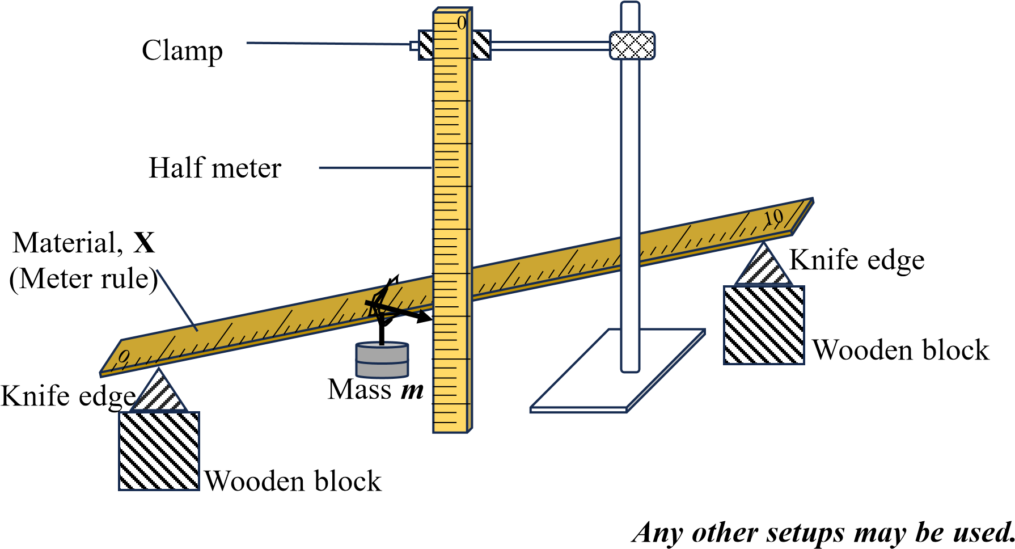

**Task:**

1. As a student of physics, carry out a scientific investigation to help the contractor tell whether the material is fit for bridge construction

**Hint**: 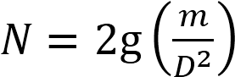

Where ***D*** is the depression and ***g***is the acceleration due to gravity.

1. Identify the sources of errors which were made

**ITEM 2**

In 2002, Major Musana John visited his elder Brother in Bukungu, whom he found using a concave mirror as a shaving mirror. To Major Musana John’s amazement, his image in the mirror was bigger. When he returns home, he decided to buy a concave mirror and use it as his shaving mirror, instead of a plane mirror. The following day, Major Musana John went to a mirror shop, whose attendants asked him for the focal length of the concave mirror he wanted to buy but he could not specify it. After asking him the purpose for which he wanted the concave mirror, it was recommended that he buys concave mirror of focal length 10 cm but unfortunately, the available concave mirrors we are not labelled with their focal lengths. However, one of these concave mirrors had been packed together with an unlabeled smaller concave mirror of the same focal length. Since the shop attendants wanted to serve their client, they were determined to find the focal length of one of the mirrors, but did not have sufficient knowledge to do so.

***Experimental set***

***-***

***up***

***Any other setup***

***s***

***may be used.***

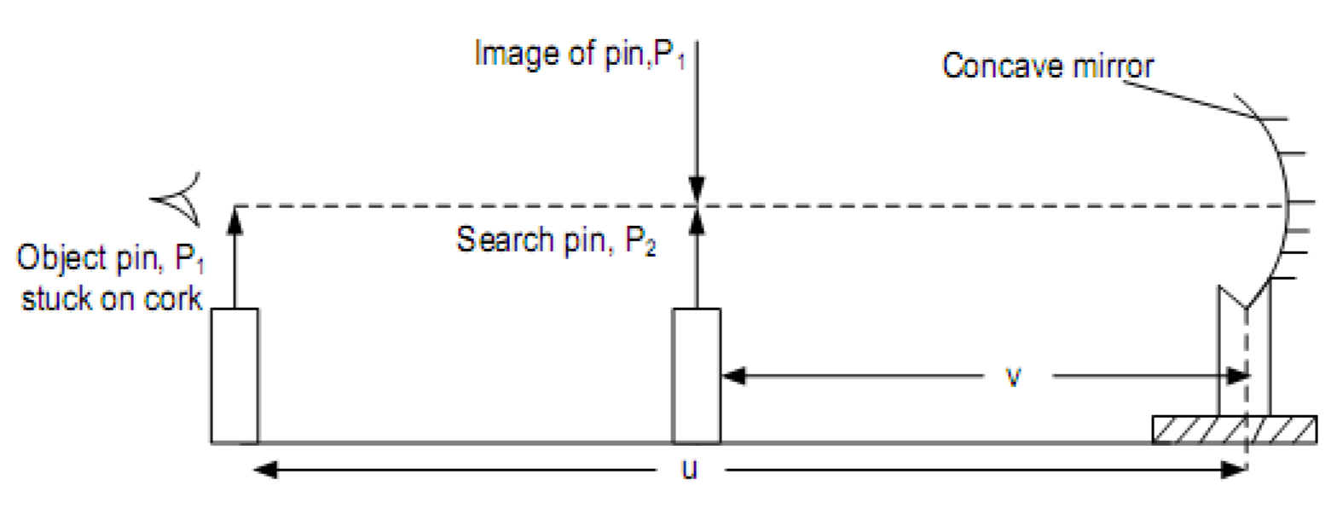

Image of pin, P

1



Search pin, P

2



Object pin, P

1

stuck on cork



***v***



***u***



Concave mirror

**Task:**

1. As a senior four physics student, carry out a scientific investigation to determine the focal length of the sample concave mirror.
2. Identify the sources of errors which were made

**Hint:** (𝑢 + 𝑣) = (𝑢𝑣)

**END**